**SECTION A (60 Marks)**

Answer only **three** questions from this section.

1. Describe, using equations where applicable, the reactions of chromium with:
2. Air.
3. Sodium hydroxide solution.
4. Sulphuric acid. (08 marks)
5. (i).Explain why chromium is considered a typical transition metal element. (02 marks)
6. State five ways in which the chemistry of chromium is similar to that of aluminium. (05 marks)
7. (i) State what is observed when a small piece of magnesium ribbon is dropped in to a solution of chromium (III) sulphate. (02 marks)
8. Explain the observation in c (i) above. (03 marks)
9. The mass spectrometer can be used to determine the relative atomic mass of elements consisting of various isotopes.
10. What is meant by the following terms: (@01 mark)
11. Relative intensities.
12. Relative abundance.
13. Relative atomic mass.
14. Briefly describe how the relative atomic mass of mass metal which consists of three isotopes can be determined using a mass spectrometer.[Diagram not required] (06 marks)
15. The relative atomic mass of magnesium with isotopes ${}_{12}^{24}{Mg}$, ${}_{12}^{25}{Mg}$& ${}_{12}^{26}{Mg}$ is 24.3.If the percentage abundance of ${}_{12}^{25}{Mg}$& ${}_{12}^{26}{Mg}$ are equal.
16. Calculate the percentage abundance of each isotope of magnesium. (01½ marks)
17. Sketch the mass spectrum of magnesium. (02 marks)
18. The table below shows the results of radioactive decay of a radioactive isotope of magnesium ${}_{12}^{26}{Mg}$.Use the data to plot a graph of log(mass) against time. (04 marks)

|  |  |  |  |  |  |  |
| --- | --- | --- | --- | --- | --- | --- |
| Mass of ${}_{12}^{26}{Mg}$ (g) | 18.7 | 14.6 | 11.3 | 8.8 | 6.9 | 5.4 |
| Time (s) | 300 | 600 | 900 | 1,200 | 1,500 | 1,800 |

1. Using the graph plotted in (d) above determine the:
2. Order of radioactive decay of ${}_{12}^{26}{Mg}$. (01 mark)
3. Rate constant and hence half-life of ${}_{12}^{26}{Mg}$. (01½ marks)
4. Original mass of ${}_{12}^{26}{Mg}$. (01 mark)
5. A saturated bromocompound, G CnH2n-1Br contains 49.08% by mass of bromine.
6. (i) Determine the molecular formula of saturated bromocompound, G. (02 marks)

(ii)Write the structural formula and name of saturated bromocompound, G. (01 mark)

1. Phenol was reacted with saturated bromocompound, G.
2. State the condition (s) for the reaction. (01 mark)
3. Write the equation and mechanism for the reaction that took place. (04 marks)
4. Saturated bromocompound, G can be distinguished from bromobenzene
5. Name the reagent (s) that can be used to distinguish the two compounds and state what is observed. (03 marks)
6. Using relevant illustrations and equations explain the difference in the observations. (05 marks)
7. Using equations while stating conditions for each step clearly show saturated bromocompound, G can be converted to Hexan-1,6-dioic acid. (04 marks)
8. Explain the following observations:
9. Hydrogen fluoride is a liquid at 19ᵒC while hydrogen chloride is a gas. (03½ marks)
10. When sodium hydroxide is added to manganese (II) chloride, a white precipitate is formed that is insoluble in excess sodium hydroxide but turns brown on standing. (04½ marks)
11. Carbon tetrachloride molecule is non-polar yet the bonds in it are polar. (04½ marks)
12. Phenol is a stronger acid than cyclohexanol. (03½ marks)
13. A mixture of 50cc of 0.1M ammonium hydroxide solution and 50cc of 0.1M solution of hydrochloric acid gives a solution which is less than seven. (04 marks)

**SECTION B (40 Marks)**

Answer only **two** questions from this section.

1. Write equations to show how each of the following compounds can be synthesized. In each case, indicate a mechanism for the reaction.



1. Name the reagent (s) that can be used to differentiate between the compounds in each of the following pairs. In each case, state what would be observed and write the equation (s) for the reaction if any when when each member of the pairs is treated with the reagent (s) stated.
2. Phenol and cyclohexanol. (04 marks)
3. Ethanal and phenylmethanal (04 marks)
4. Using equations while stating conditions for each step clearly show how 2-bromopropane can be converted to phenol. (04 marks)
5. The melting points of magnesium, silicon, & sulphur are 650ᵒC, 1,423ᵒC & 120ᵒC respectively. Explain the difference in the melting of the elements. (06 marks)
6. (i).Name the type of bond that exists in the hydride of magnesium, silicon & sulphur. (01½ marks)

(ii).Write the equation to show the reaction of any of the hydride with water. (04½ marks)

1. Describe the reactions of the oxide of silicon with: (08 marks)
2. Hydrofluoric acid.
3. Sodium hydroxide solution.
4. Water
5. (i).Write balanced equations to illustrate the main stages of the contact process. (03 marks)

(ii).Explain the conditions used in the contact process to ensure maximum yield. (05 marks)

1. Sulphuric acid vapour dissociates when heated according to the equation below:



Write an expression for the equilibrium constant,Kp for the reaction and state its SI units. (01½ marks)

1. The following data shows the equilibrium partial pressure of sulphuric acid vapour, steam and sulphur trioxide gas at two different temperature and pressure of 1atm:

|  |  |  |  |
| --- | --- | --- | --- |
| Temperature (K) | Partial pressures (Pa) | | |
| H2SO4 | H2O | SO3 |
| 400 | 4.5 | 3.2 | 2.9 |
| 493 | 470 | 300 | 270 |

1. Calculate the equilibrium constant,Kp at each temperature. Hence deduce with an explanation whether the dissociation sulphuric acid vapour is exothermic or endothermic. (04 marks)
2. Explain the effect of increasing pressure on the equilibrium position and equilibrium constant, kp at 400K. (02½ marks)
3. (i).Sketch the structure and name of the shape of the sulphuric acid molecule. (02 marks)
4. Explain why sulphuric acid molecule adopts the shape named. (02 marks)
5. (i) What is meant by the term Ore? (01 mark)

(ii)Write the formula and name of one ore from which copper is extracted. (01 mark)

1. Describe how pure copper can be extracted from the (a) (ii) above. (11½ marks)
2. Discuss the reactions of copper with:
3. Nitric acid.
4. Concentrated hydrochloric acid. (04 marks)
5. Few drops of potassium hexacyanoferrate (II) solution were added to copper (II) sulphate solution:
6. State what would be observed. (01 mark)
7. Write equation for the reaction. (01½ marks)

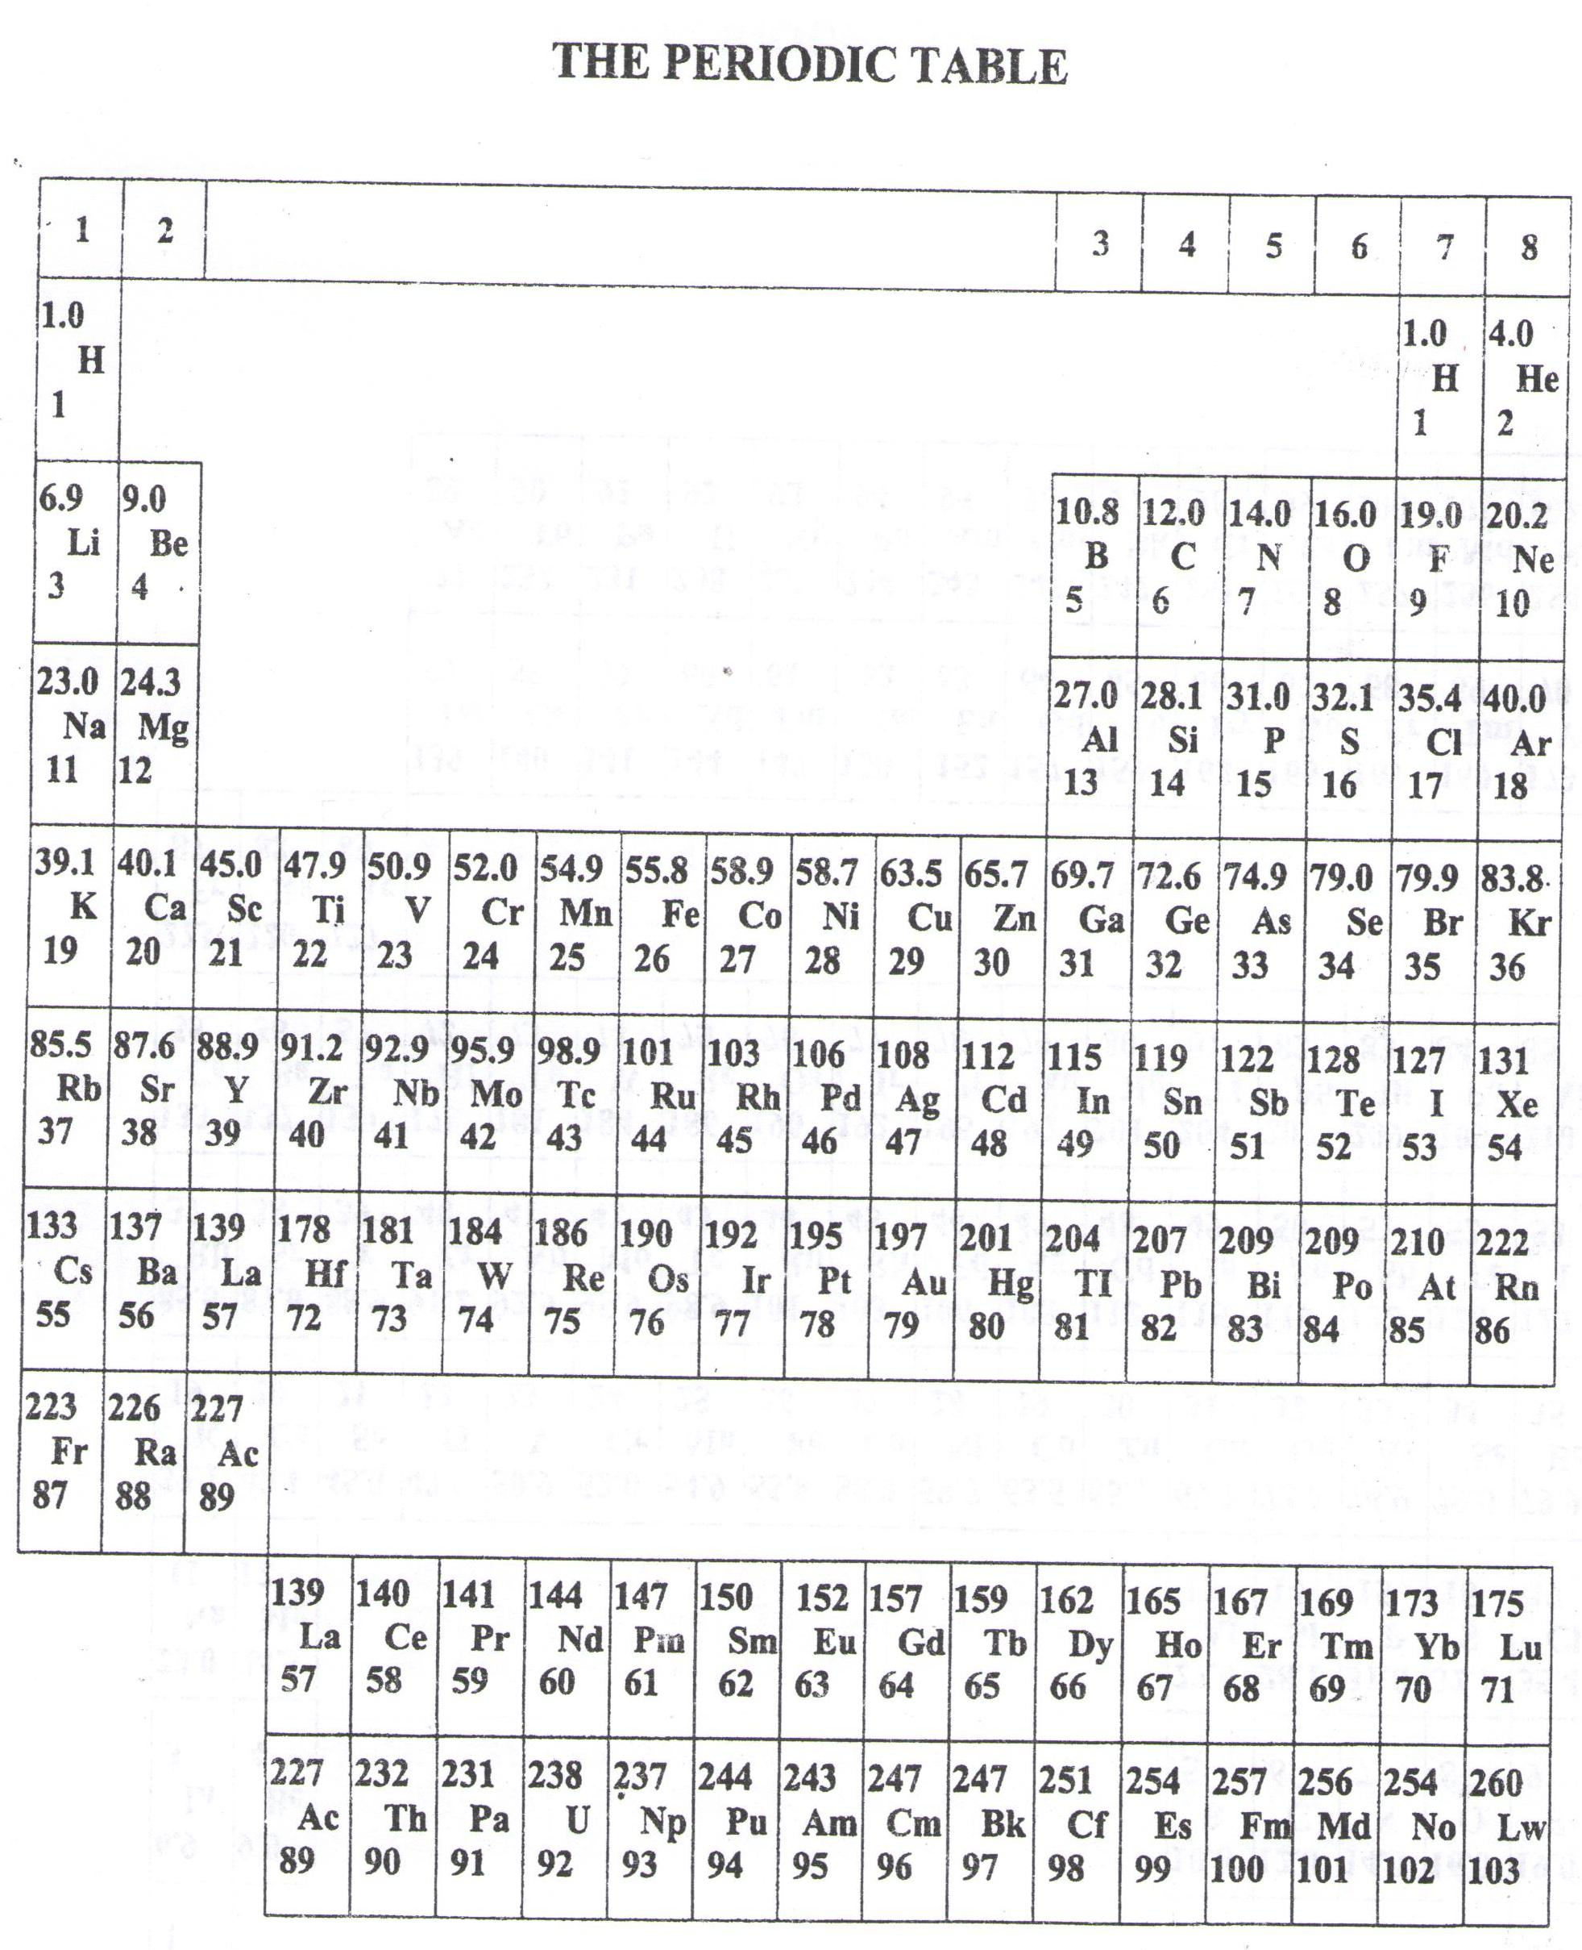

* ===END===

WELCOME TO SENIOR SIX, YEAR 2023

This is the last page of the printed paper, Page 06